**Spring ANSO Mixer**

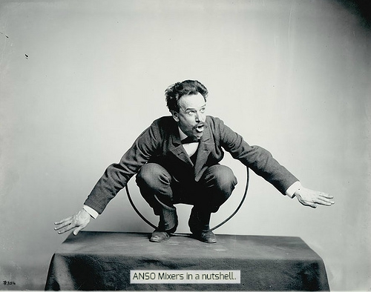

**Hollander third floor sitting area!**

**Faculty and students invited.**

**Come for the food!**

**Stay to appease Durkheim!**

**Wednesday, Feb. 15th 7-9 PM**